**1.      Client Total Exposure**

|  |  |  |  |  |  |  |  |  |  |  |  |
| --- | --- | --- | --- | --- | --- | --- | --- | --- | --- | --- | --- |
| **Client Total Exposure** | | | |  | |  |  |  |  | |  |
| **Client Name:** | XXXXXXXXXXXX XXXXXXXX XXXXXXX | | | | | |  |  |  | |  |
| **NIC Number:** | XXXXXXXXXXXX | |  | |  | |  |  |  | |  |
|  |  |  |  | |  | |  |  |  | |  |
| **Ticket No** | **Ticket Date** | **Closed date** | **Pawn Advance** | | **Capital Outstanding** | | **Interest Accrued** | **Interest Received** | **Interest**  **Receivable** | **No Of Item(s)** |  |
|  |  |  |  | |  | |  |  |  |  |  |
|  |  |  |  | |  | |  |  |  |  |  |
|  |  |  |  | |  | |  |  |  |  |  |
|  |  |  |  | |  | |  |  |  |  |  |
|  |  |  |  | |  | |  |  |  |  |  |
|  |  |  |  | |  | |  |  |  |  |  |
|  |  |  |  | |  | |  |  |  | |  |
| **Total** |  |  |  | |  | |  |  |  | |  |
|  |  |  |  | |  | |  |  |  | |  |
|  |  |  |  |  |  |  |  |  |  |  |  |

This screen can be call for given client.

Add this popup screen to the following screens right side of client name as follows

•         Client Main

•         Ticket Master

•         Authorize Ticket

•         Info Console

**Other Charge Screen**

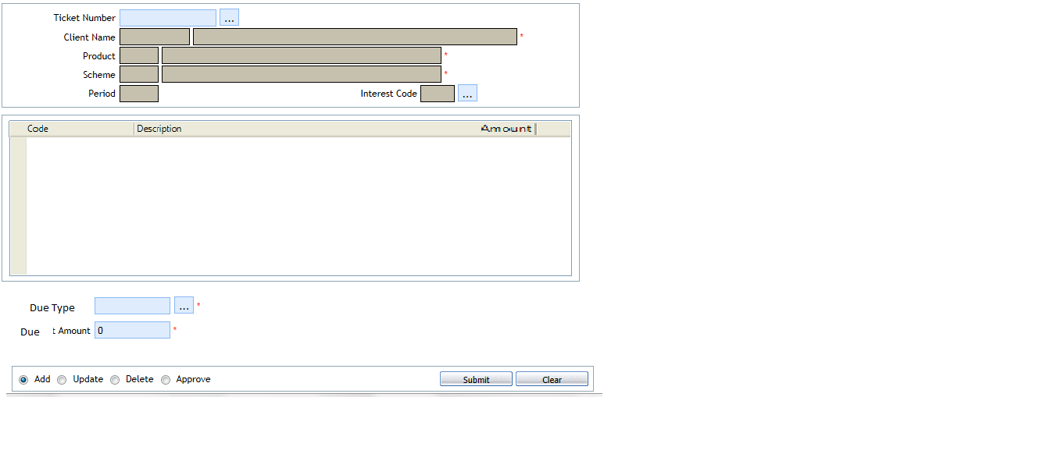

1. Using This screen user can debit other amount (other than CAP,INT) to the Ticket
2. Due type can be added to ticket after define in the due type screen
3. User can Delete / Update the amount unless the due amount not been settled fully or partly